A Minor Project Proposal Report on
VoteChain

Submitted in Partial Fulfillment of the Requirements for
The Degree of Bachelor of Engineering in Computer Engineering
Under Pokhara University

Submitted by:
Achieve Paudel
Abhash Basnet
Rajib Raut
Sandesh Paudel
Ayush Jasraj

Date:
07/05/2025


Department of Computer Engineering
UNIVERSAL ENGINEERING AND SCIENCE COLLEGE

Abstract
This proposal outlines the design of a Secure Blockchain Voting System aimed at modernizing electoral processes by integrating blockchain technology with advanced cryptographic techniques to ensure security, transparency, and voter anonymity. The system leverages decentralized ledger technology to eliminate central points of failure while maintaining an immutable and publicly auditable record of votes. By incorporating zero-knowledge proofs (ZKPs) and end-to-end encryption, the platform guarantees voter privacy, allowing individuals to verify their votes without exposing their choices. Prior research highlights blockchain's potential to reduce fraud, enhance transparency, and enable real-time verification of election results. Our approach builds on these findings by combining tamper-resistant vote recording with decentralized consensus mechanisms, ensuring that votes remain secure and unaltered throughout the process. Additionally, the system provides end-to-end verifiability, enabling voters to confirm their ballots were counted accurately while maintaining secrecy. The expected outcome is a functional prototype that demonstrates improved election integrity, fostering greater public trust in democratic processes. By merging blockchain's inherent security with privacy-preserving cryptography, this system aims to set a new standard for secure, transparent, and trustworthy voting in the digital age.

Contents

Abstract 2
1. Introduction 1
2. Problem Statement 2
3. Project Objectives 3
4. Scope 4
5. Literature Review 5
6.Methodology 6
7. System Flowchart 7
8. Gantt Chart 8
9. Expected Outcomes 9
10. Use Case Diagram 10
11. Conclusion 10
12. References 11

1. Introduction
Elections form the cornerstone of democratic governance, requiring utmost integrity, security, and public trust to ensure legitimate outcomes. Traditional voting systems—whether paper ballots, ballot boxes, or electronic voting machines (EVMs)—depend heavily on centralized authorities and physical safeguards, making them susceptible to tampering, fraud, and single points of failure. While electronic voting solutions improve accessibility and efficiency, they introduce new vulnerabilities, including cyberattacks, unauthorized vote manipulation, and a lack of verifiable audit trails.
Blockchain technology presents a transformative solution to these challenges by offering a decentralized, tamper-resistant ledger where each vote is immutably recorded. Researchers highlight blockchain’s ability to provide end-to-end verifiability, ensuring that votes remain non-repudiable while maintaining transparency and security. Early implementations, such as those in Estonia and Switzerland, have demonstrated blockchain’s potential to enhance electoral integrity by enabling secure, auditable voting processes without compromising voter anonymity.
In this project, we propose a blockchain-based voting system that leverages cryptographic techniques such as zero-knowledge proofs (ZKPs) and encryption to protect voter privacy while creating a publicly verifiable, immutable record of election results. By eliminating centralized control and ensuring tamper-proof vote storage, our solution aims to restore trust in electoral systems, providing a secure, transparent, and scalable alternative to conventional voting methods.

2. Problem Statement

1. Centralization & Fraud Risk
- Nepal’s vote counting relies on centralized authorities, increasing risks of manipulation.
- Past elections have faced allegations of ballot stuffing and miscounting.
- Physical ballots can be lost, altered, or tampered with during transportation.
2. Voter Privacy vs. Transparency
- While votes are supposed to be secret, local influences and voter intimidation persist.
- No secure way to verify votes were counted correctly without compromising anonymity.
3. Vote Tampering & Double Voting
- Fake voter IDs and duplicate voting have been reported in past elections.
- Manual verification processes are slow and prone to human error.
4. Lack of Auditability
- No real-time public verification of vote counts.
- Disputes lead to delayed results and legal battles, reducing trust in outcomes.
5. Low Trust & Voter Engagement
- Allegations of fraud decrease public confidence in election results.
- Remote and marginalized communities face difficulties in voting securely.

3. Project Objectives

- Develop a Blockchain Voting Platform
  - Build a prototype leveraging distributed ledger technology to record votes immutably.
  - Use smart contracts to automate vote tallying and enforce election rules.
- Ensure Voter Anonymity
  - Implement cryptographic techniques (e.g., homomorphic encryption, zero-knowledge proofs) to dissociate voter identity from ballots.
  - Use pseudonymous identities (e.g., hashed voter IDs) to protect privacy.
- Prevent and Detect Fraud
  - Double-voting: Assign time-limited, single-use tokens to voters.
  - Identity theft: Integrate secure authentication (e.g., biometrics or multi-factor auth).
  - Tampering: Use consensus mechanisms (e.g., Proof-of-Authority) to validate transactions.
- Maintain Transparency & Auditability
  - Provide a public, immutable ledger for real-time vote verification.
  - Enable third-party auditors to validate results without compromising anonymity.
- User Authentication & Integrity
  - Secure registration: Verify voter eligibility via government-issued IDs (e.g., hashed/off-chain storage).
  - Authentication: Use digital signatures or OTPs for ballot submission.
- Usability & Reliability
  - Design an intuitive UI/UX (e.g., web/mobile interfaces) for voters.
  - Conduct stress testing and simulations to ensure scalability and uptime.

4. Scope
- System Architecture
  - Design a scalable, secure blockchain network (Ethereum, Hyperledger, or custom) supporting nationwide voting.
  - Hybrid approach (on-chain vote recording, off-chain computation for efficiency).
- Voter Registration & Identity Verification
  - Integration with national ID/digital identity systems (e.g., Aadhaar, e-Estonia).
  - Biometric/KYC verification to prevent duplicate/fraudulent registrations.
- Voting Mechanism
  - Multi-platform voting interface (web/mobile) with end-to-end encryption.
  - Support for in-person (biometric/PIN) and remote (OTP/crypto-wallet) authentication.
- Consensus & Immutable Ledger
  - Proof-of-Authority (PoA) or delegated Byzantine Fault Tolerance (dBFT) for fast, government-auditable consensus.
  - Tamper-proof vote storage with cryptographic hashing.
- Vote Tallying & Results
  - On-chain smart contracts or zero-knowledge proofs (ZKPs) for anonymous, auditable tallying.
  - Real-time results dashboard with verifiable correctness.
- Security & Compliance
  - Resistance to DDoS, Sybil, and coercion attacks.
  - Compliance with national election laws (e.g., anonymity, audit trails).
- Deployment & Scalability
  - Stress-tested infrastructure for millions of concurrent voters.
  - Disaster recovery and backup protocols.

5. Literature Review
Recent literature on blockchain voting highlights both opportunities and challenges:
- Blockchain Advantages
- Fraud Reduction: Immutable ledger prevents tampering (ResearchGate).
- Decentralization: No single point of failure; votes verified by nodes (ResearchGate).
- Transparency: Real-time tracking and auditable results (ResearchGate).
- Anonymity: Secure voter identity protection (ResearchGate).

- Cryptographic Security:
- Privacy-Preserving Counts: Homomorphic encryption enables tallying votes without revealing individual choices (Springer).
- Zero-Knowledge Proofs (ZKPs): Verify vote validity without exposing data (Springer).
- Smart Contracts: Automate voting rules (e.g., Ethereum) for tamper-proof execution.
- Confidentiality + Integrity: Encrypted ballots with auditable results maintain both security and transparency.

- Privacy and Trust Issues:
- Public Ledger: Enables vote auditing while cryptography (e.g., ZKPs, encryption) prevents voter-vote linkage (PMC).
- Verifiability: Voter receipts or audit logs let users confirm ballot inclusion without revealing choices (PMC).
- Trust Balance: Full transparency in tallying + strict anonymity in voting.

- Implementations and Examples:
- Estonia’s i-Voting & Swiss Trials: Proved blockchain enhances transparency and trust in small-scale elections (Springer).
- Key Requirement: Secure digital identity systems are crucial for authentication.
- Outcome: Successful vote recording while maintaining auditability.

- Challenges:
- Scalability Issues: Current blockchains lack throughput for national elections (PMC).
- Usability Barriers: Complex for average voters; requires tech literacy (PMC).

Methodology

We adopt an iterative development model to incrementally build and test a secure blockchain voting system.

Phases:
- Requirement Analysis
  - Gather functional & security needs (e.g., anonymity, auditability).
  - Define system specs based on literature and stakeholder input.

- System Design
  - Design blockchain architecture (e.g., Ethereum/Hyperledger).
  - Plan smart contracts, voter credentials, and ballot data models.

- Incremental Implementation & Testing
  - Cycle 1: Set up blockchain + voter registration module.
  - Cycle 2: Develop voting interface + encrypted ballot submission.
  - Cycle 3: Implement vote tallying (smart contract/off-chain).
  - Cycle 4: Integrate features (voter receipts, result publishing).
  - Testing: Security/unit tests after each cycle (e.g., double-voting checks).

- Evaluation
  - End-to-end testing with sample elections.
  - Verify anonymity, tally accuracy, and performance.

- Documentation
  - Maintain design/code docs + final report & user manual.

(Flexible for adjustments during development.)

7. System Flowchart
The voting system operates through the following logical flow:
- Voter Registration: An eligible voter applies for registration. The system verifies identity (e.g., ID number) and, if valid, registers the voter and issues a unique cryptographic identity (blockchain wallet address).
- Start Election: The election administrator configures election details (candidates, voting period) and starts the election on the blockchain network.
- Vote Casting: During the voting period, a registered voter logs in, views the ballot, and selects their candidate. The selection is encrypted (using the voter’s private key or a scheme like ring signatures) and submitted as a blockchain transaction.
- Transaction Validation: Blockchain nodes receive the vote transaction. Each node verifies the voter’s eligibility and that this voter has not voted already (preventing double-voting). Valid transactions are added to a new block once consensus is reached.
- Recording Votes: The validated vote is permanently recorded in the blockchain. The public ledger now contains an encrypted vote record and a proof of its validity.
- Vote Tallying: After the voting period ends, a tally process is triggered (either via a smart contract or by decrypting aggregated ballots). All votes are counted, and totals per candidate are computed without linking votes to voters.
- Result Publication: The final results are recorded on the blockchain and published. Because the ledger is public, anyone can verify that the tally matches the stored votes.
- End: The system concludes the election. Voters can review the published ledger to confirm their vote was recorded (using any provided voter receipt), ensuring transparency.
This flow ensures that every vote is securely handled: from identity verification to vote encryption, blockchain validation, and transparent result reporting. Any invalid or duplicate vote is detected and rejected during the transaction validation step.

8. Gantt Chart
The project schedule is expected to span 10 weeks, with tasks as follows:
- Weeks 1–2: Requirement Analysis & Design. Define system requirements, choose blockchain platform, and create design documents.
- Weeks 3–4: Blockchain Setup & Voter Registration. Configure the blockchain network (test environment) and develop the voter registration/authentication module.
- Weeks 5–6: Voting Module Implementation. Build the user interface for casting votes, implement encryption of ballots, and enable vote submission to the blockchain.
- Weeks 7–8: Tally & Results Module. Develop the vote-counting mechanism (e.g., smart contract) and result display features.
- Week 9: Integration & Testing. Integrate all modules, conduct system testing (functionality and security), and resolve any defects.
- Week 10: Finalization & Documentation. Final testing, prepare project documentation, user guide, and project report.
Each phase overlaps slightly to allow iterative refinement. This timeline is a guideline; actual progress may adjust based on complexity encountered.
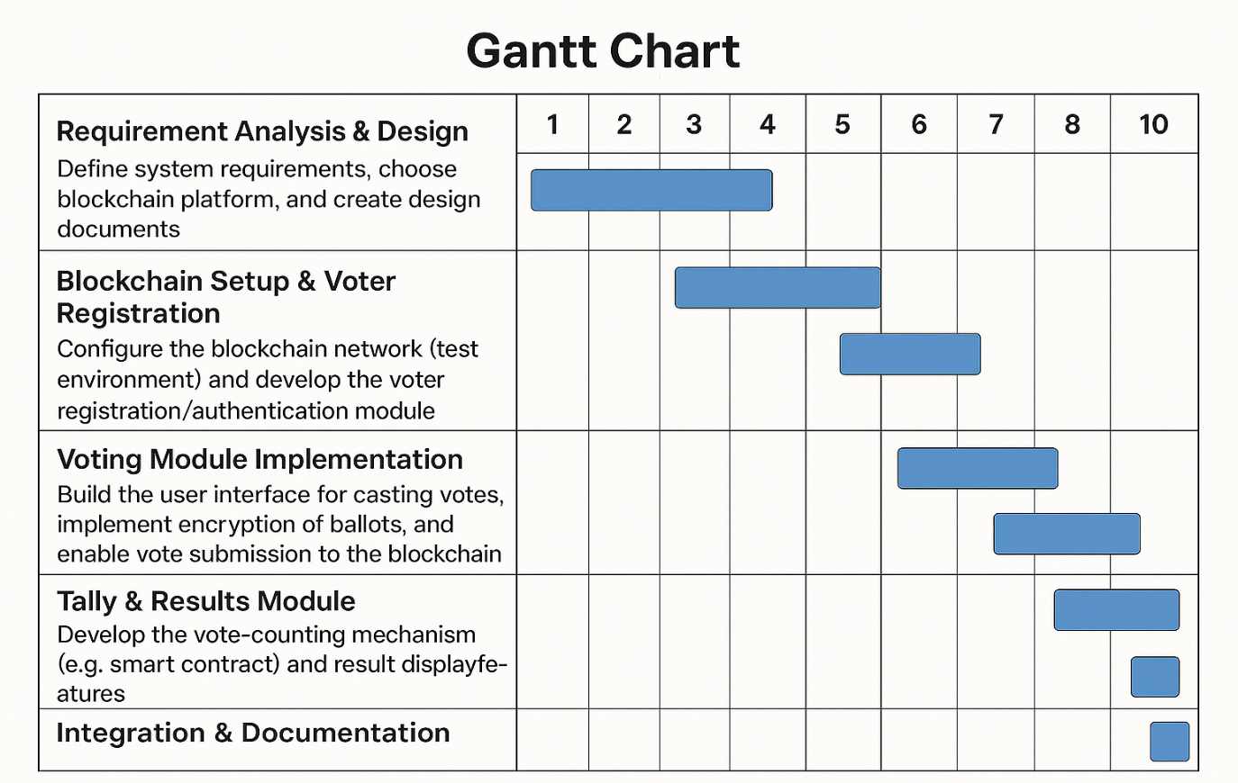

9. Expected Outcomes
Upon completion, we expect the following outcomes:
- Functional Prototype: A working proof-of-concept voting application with a blockchain backend. Voters can register, log in, and cast votes through a user interface.
- Secure Vote Storage: Each vote is cryptographically secured and stored on a distributed ledger. Votes are immutable once recorded.
- Anonymity Mechanisms: Voter identities are decoupled from ballots using encryption or anonymity schemes (e.g., ring signatures). The system demonstrates that vote contents remain private even though the ledger is public.
- Auditable Election Records: A transparent record of all votes and the final tally, viewable on the blockchain. Observers can verify that the result was computed correctly from the recorded votes.
- Fraud Prevention: The system detects and rejects invalid votes (e.g., duplicates or from unregistered voters).
- Documentation: A technical report detailing design decisions, security analysis, and user instructions.
- Evaluation Results: Analysis of system performance (e.g., transaction processing time) and discussion of any limitations.
These deliverables will demonstrate the feasibility of using blockchain to enhance election security and trust. The prototype can be used for further research or small-scale deployments.

10. Use Case Diagram
The major actors and use cases in this system include:
- Voter: Registers with the system, authenticates, casts a vote, and receives confirmation. Use Cases: Register Voter, Login, Cast Ballot, Confirm Vote.
- Election Administrator: Sets up and manages the election. Use Cases: Define Election (candidates, schedule), Start Election, End Election, Trigger Tally, Publish Results.
- Observer/Auditor: Any stakeholder (e.g., independent auditor) who views the blockchain. Use Cases: View Public Ledger, Verify Result. They ensure the election process was fair.
- Blockchain Network: Acts as an automated system entity. Use Cases: Validate Transactions, Append Blocks, Maintain Ledger. (While not a human actor, the network enforces the rules behind the scenes.)
In interactions, for example, a Voter actor uses the Cast Ballot use case to submit an encrypted vote, which the Blockchain Network actor then validates and records. The Administrator uses Publish Results after tallying. The Observer can execute Verify Result by checking the ledger entries. This use case structure ensures all roles in the election process are covered and their interactions with the blockchain system are clear.

11. Conclusion
This project proposes a secure, transparent voting platform that leverages blockchain to address shortcomings of traditional elections. By combining a decentralized ledger with strong cryptographic privacy techniques, the system will produce an immutable, verifiable record of votes while keeping individual ballots secret. Expected results include a working prototype demonstrating improved security (resistance to tampering) and increased voter trust through transparency. In summary, the Secure Blockchain Voting System aims to make elections more trustworthy and accessible. If successful, it could lay the groundwork for future enhancements, such as scaling to larger electorates and integrating user-friendly authentication methods, thereby contributing to more robust democratic processes.

12. References
- S. Akinbohun, S. Apeh, E. O. Olaye, O. Dele-Ogbeide, “Literature Review of Blockchain-Based Voting System: Framework and Concept”, Int. J. Adv. Trends Comput. Sci. Eng., vol. 12, no. 1, 2023researchgate.net.
- H. O. Ohize et al., “Blockchain for securing electronic voting systems: a survey of architectures, trends, solutions, and challenges”, Cluster Computing, vol. 28, 2025link.springer.comlink.springer.com.
- P. McCorry, S. F. Shahandashti, F. Hao, “A scalable implementation of anonymous voting over Ethereum blockchain”, J. Cybersecurity, vol. 7, 2021pmc.ncbi.nlm.nih.gov.
- A. A. Ali et al., “Blockchain for Electronic Voting System—Review and Open Research Challenges”, Security and Communication Networks, 2021pmc.ncbi.nlm.nih.govpmc.ncbi.nlm.nih.gov.

